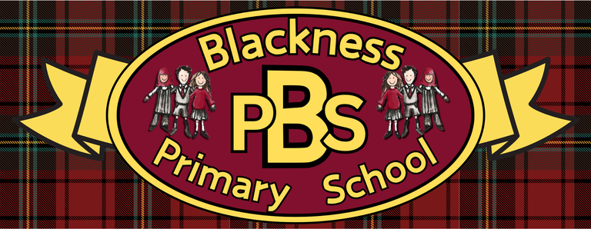 “Everyone Here Matters”
P2 Health and Wellbeing Grid
Developing Healthy Choices  Design a fruit smoothie that has at least 4 different fruits. Explain why you have chosen those fruits (think about their smell, taste, texture etc). | Nutritional Needs  How many dairy items can you find in your fridge/freezer at home? Can you rank them from healthiest to least healthy? | Keeping safe/hygienic  Teeth hygiene  Play-Doh Flossing: Put Play-Doh between toy blocks or LEGO bricks and use real floss to pull the "food" out. | The journey of food  Grain Chain  Where does bread come from?  Can you order the process correctly?  (see sheet below)
Food technology  Help to cook a meal at home. Remember to wash your hands and follow the instructions given by an adult. | Physical Activity  Cosmic Kids Yoga - YouTube  Take part in a yoga session at home. | Social Wellbeing  Go for a walk with your family. Can you spot signs of the season as you walk? Draw a picutre/write a list of what you noticed. | Zones of Regulation  Match the face to the feeling. Colour the face to show what zone that emotion is part of.  (see activity below)
Healthy Relationships  Who’s been framed?  Gather some loose materials indoors or out and create a portrait of someone you know. Can anyone guess who it is? | Mental and Emotional Wellbeing  Looking after our mental wellbeing is really important as well as staying physically fit. Try taking part in a BBC Moodbooster!  Moodboosters | Staying Safe  Safety Scavenger hunt  Walk around your house identifying anything that could cause harm if you were not aware of it! How many different hazards did you spot? | Focus and Concentration  Exercise your brain and your fingers with this link:  Brain Activation Exercises for Kids | Yoga for Right & Left Brain | Finger Yoga | Yoga Guppy

Ready Respectful Safe

Ready Respectful Safe

=
